**Assignment (Day 2)**

**TASK: 01**

**Create directories which would have the following structure by using only mkdir command:**

**HIERARCHY:**

consultadd/

|-- Python

| `-- Django

| `-- restframework

|-- java

| `-- springboot

|-- javascript

| `-- angular

| `-- react

|-- SQL

| `-- mysql

`-- bootcamp

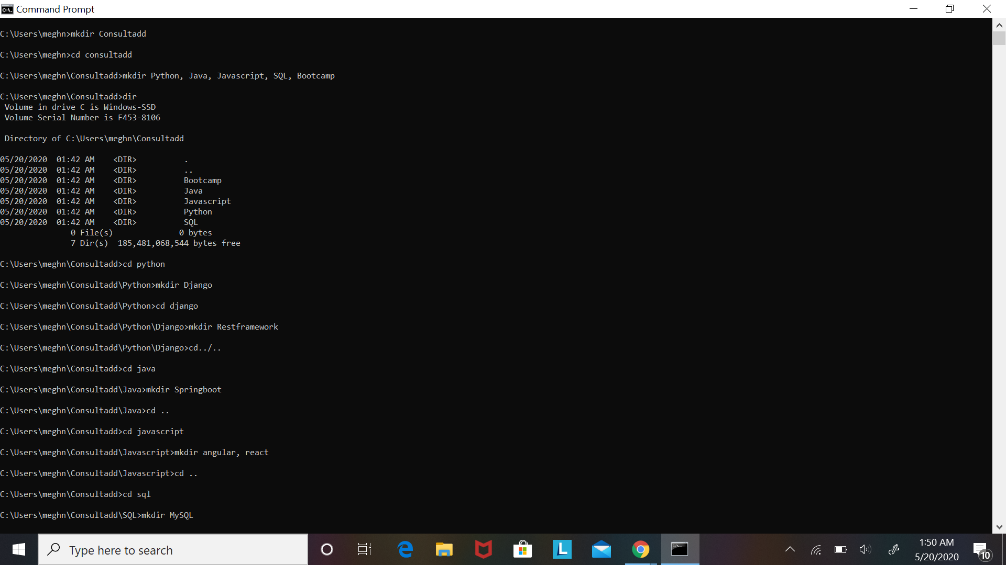

**TASK 02:**

* Create Directory called consultadd
* Inside that create 5 more directories named them as dir1, dir2, dir3, dir4 and dir5
* What would be the output of Long Listing after creating these directories?
* List all the directories with ls and echo * and see the difference.
* Create a 2 files named them file1.txt and file2.txt inside dir3
* Move dir5 into the dir3
* Remove dir 3 after moving all files from dir3 to dir2.
* Go to the dir2 and create one more file with name index.html
* Move to top level directory
* Check the permission of all files and directory from current place make sure when you do **pwd** it should be on consultadd
* Rename all files of dir2 with extension of .txt to .py

C:\Users\meghn>mkdir Consultadd

C:\Users\meghn>cd consultadd

C:\Users\meghn\Consultadd>mkdir dir1, dir2, dir3, dir4, dir5

C:\Users\meghn\Consultadd>dir

Volume in drive C is Windows-SSD

Volume Serial Number is F453-8106

Directory of C:\Users\meghn\Consultadd

05/20/2020 03:26 AM <DIR> .

05/20/2020 03:26 AM <DIR> ..

05/20/2020 03:26 AM <DIR> dir1

05/20/2020 03:26 AM <DIR> dir2

05/20/2020 03:26 AM <DIR> dir3

05/20/2020 03:26 AM <DIR> dir4

05/20/2020 03:26 AM <DIR> dir5

0 File(s) 0 bytes

7 Dir(s) 185,852,911,616 bytes free

C:\Users\meghn\Consultadd>cd dir3

C:\Users\meghn\Consultadd\dir3>mkdir file1.txt, file2.txt

C:\Users\meghn\Consultadd\dir3>cd..

C:\Users\meghn\Consultadd>move dir5 C:\users\meghn\consultadd\dir3

1 dir(s) moved.

C:\Users\meghn\Consultadd>cd dir3

C:\Users\meghn\Consultadd\dir3>dir

Volume in drive C is Windows-SSD

Volume Serial Number is F453-8106

Directory of C:\Users\meghn\Consultadd\dir3

05/20/2020 03:56 AM <DIR> .

05/20/2020 03:56 AM <DIR> ..

05/20/2020 03:26 AM <DIR> dir5

05/20/2020 03:27 AM <DIR> file1.txt

05/20/2020 03:27 AM <DIR> file2.txt

0 File(s) 0 bytes

5 Dir(s) 185,856,200,704 bytes free

C:\Users\meghn\Consultadd\dir3>cd..

C:\Users\meghn\Consultadd>move dir3\file1.txt dir2\

1 dir(s) moved.

C:\Users\meghn\Consultadd>move dir3\file2.txt dir2\

1 dir(s) moved.

C:\Users\meghn\Consultadd>move dir3\dir5 dir2\

1 dir(s) moved.

C:\Users\meghn\Consultadd>rmdir dir3

C:\Users\meghn\Consultadd>cd dir2

C:\Users\meghn\Consultadd\dir2>mkdir index.html

C:\Users\meghn\Consultadd\dir2>cd

C:\Users\meghn\Consultadd\dir2

C:\Users\meghn\Consultadd\dir2>cd/

C:\>icacls users

users NT AUTHORITY\SYSTEM:(OI)(CI)(F)

BUILTIN\Administrators:(OI)(CI)(F)

BUILTIN\Users:(RX)

BUILTIN\Users:(OI)(CI)(IO)(GR,GE)

Everyone:(RX)

Everyone:(OI)(CI)(IO)(GR,GE)

Successfully processed 1 files; Failed processing 0 files

C:\>cd users\meghn\consultadd

C:\Users\meghn\Consultadd>echo %cd%

C:\Users\meghn\Consultadd

C:\Users\meghn\Consultadd>dir

Volume in drive C is Windows-SSD

Volume Serial Number is F453-8106

Directory of C:\Users\meghn\Consultadd

05/20/2020 04:01 AM <DIR> .

05/20/2020 04:01 AM <DIR> ..

05/20/2020 03:26 AM <DIR> dir1

05/20/2020 04:02 AM <DIR> dir2

05/20/2020 03:26 AM <DIR> dir4

0 File(s) 0 bytes

5 Dir(s) 185,852,563,456 bytes free

C:\Users\meghn\Consultadd>cd dir2

C:\Users\meghn\Consultadd\dir2>dir

Volume in drive C is Windows-SSD

Volume Serial Number is F453-8106

Directory of C:\Users\meghn\Consultadd\dir2

05/20/2020 04:02 AM <DIR> .

05/20/2020 04:02 AM <DIR> ..

05/20/2020 03:26 AM <DIR> dir5

05/20/2020 03:27 AM <DIR> file1.txt

05/20/2020 03:27 AM <DIR> file2.txt

05/20/2020 04:02 AM <DIR> index.html

0 File(s) 0 bytes

6 Dir(s) 185,852,301,312 bytes free

C:\Users\meghn\Consultadd\dir2>ren file1.txt file1.py

C:\Users\meghn\Consultadd\dir2>ren file2.txt file2.py

C:\Users\meghn\Consultadd\dir2>dir

Volume in drive C is Windows-SSD

Volume Serial Number is F453-8106

Directory of C:\Users\meghn\Consultadd\dir2

05/20/2020 04:14 AM <DIR> .

05/20/2020 04:14 AM <DIR> ..

05/20/2020 03:26 AM <DIR> dir5

05/20/2020 03:27 AM <DIR> file1.py

05/20/2020 03:27 AM <DIR> file2.py

05/20/2020 04:02 AM <DIR> index.html

0 File(s) 0 bytes

6 Dir(s) 185,851,891,712 bytes free

**TASK: 03**

* What is Nano Editor?
  + How to create a sample file in Nano Editor?
  + How to save file?

Nano editor is an easy to use command line text editor which includes functionalities like syntax highlighting, multiple buffers, search and replace with regular expression support, spell checking and more. Nano editor is ideal for making small changes to existing configuration files or for writing short plain text files.

To create a sample file:

nano file1.txt

To save the file:

Press Ctrl + O

* What is Vi Editor?
  + Operation in Vi Editor

The VI editor is the most popular and classic text editor in the Linux family. It is available in almost all Linux Distributions. It works the same across different platforms and Distributions. It is user-friendly.

1. Command mode commands which cause action to be taken on the file
2. Insert mode in which entered text is inserted into the file.

In the command mode, every character typed is a command that does something to the text file being edited; a character typed in the command mode may even cause the vi editor to enter the insert mode. In the insert mode, every character typed is added to the text in the file; pressing the <Esc> (Escape) key turns off the Insert mode.

While there are a number of vi commands, just a handful of these is usually sufficient for beginning vi users. To assist such users, this Web page contains a sampling of basic vi commands. The most basic and useful commands are marked with an asterisk (* or star) in the tables below. With practice, these commands should become automatic.

**TASK: 04**

* Type **finger** to see your account and name.
* Type **cal** to see this month’s calendar.
* Create a file and give a name random.txt to it with content into it which say “Hello Welcome to the Consultadd Inc Bootcamp”.
* Display the same content using **cat** command.

**TASK: 05**

* Explain the workflow of the Internet in one paragraph.

The Internet works through a packet routing network in accordance with the Internet Protocol (IP), the Transport Control Protocol (TCP) and other protocols.

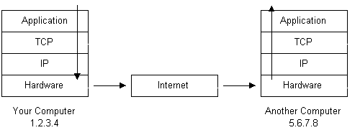

In basic terms, the internet is a global interconnected collection of networks that communicate using internet protocols. You can think of it as a network of networks where every network is a node.

However, new devices and technologies have created new ways to connect to networks through the internet. A combination of them is often used to make these connections.

* How LAN is different from the WAN network?

|  |  |  |
| --- | --- | --- |
|  | **LAN** | **WAN** |
| **Stands For** | Local Area Network | Wide Area Network |
| **Covers** | Local areas only | Large geographic areas |
| **Speed** | High speed (1000 mbps) | Less speed (150 mbps) |
| **Data transfer rates** | LANs have a high data transfer rate. | WANs have a lower data transfer rate compared to LANs. |
| **Connection** | One LAN can be connected to other LANs over any distance via telephone lines and radio waves. | Computers connected to a wide-area network are often connected through public networks, such as the telephone system. They can also be connected through leased lines or satellites. |
| **Data Transmission Error** | Experiences fewer data transmission errors | Experiences more data transmission errors as compared to LAN |
| **Ownership** | Typically owned, controlled, and managed by a single person or organization. | WANs (like the Internet) are not owned by any one organization but rather exist under collective or distributed ownership and management over long distances. |
| **Geographical Spread** | Have a small geographical range and do not need any leased telecommunication lines | Have a large geographical range generally spreading across boundaries and need leased telecommunication lines |
| **Bandwidth** | High bandwidth is available for transmission. | Low bandwidth is available for transmission. |
| **Congestion** | Less congestion | More congestion |